Release OpenXcom 1.0 Installation - Equal Terms Mod

# Installing OpenXcom

First go to: [http://openxcom.org/downloads-milestones](http://openxcom.org/downloads-milestones/)/ and download the Windows Installer.

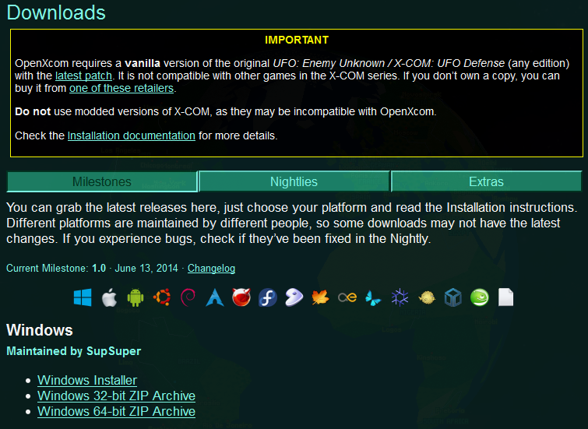

Run the installer – Unselect the ‘Data Patch’ option. (We’ll install it later)

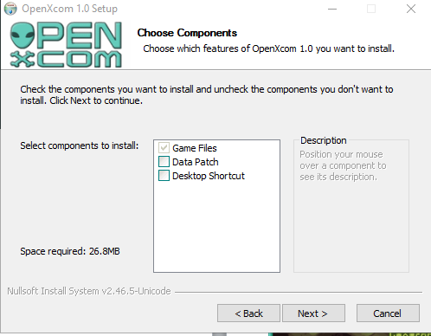

# Installing the Xcom Resources

The installer should do this, but if not:

Open and copy over the following folders from your original X-Com install

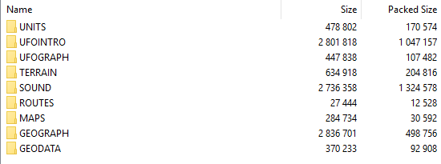

GEODATA, GEOGRAPH, MAPS, ROUTES, SOUND, TERRAIN, UFOGRAPH, UFOINTRO, UNITS

Into the ‘OpenXcom\UFO folder’.

# Game Settings

Run the game.

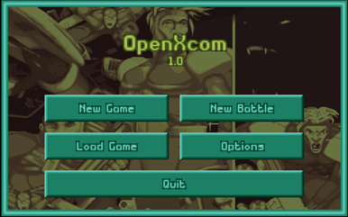

Go to options and set up your sounds and graphics (along with filters) to your liking. Start a game, save it and then exit the game.

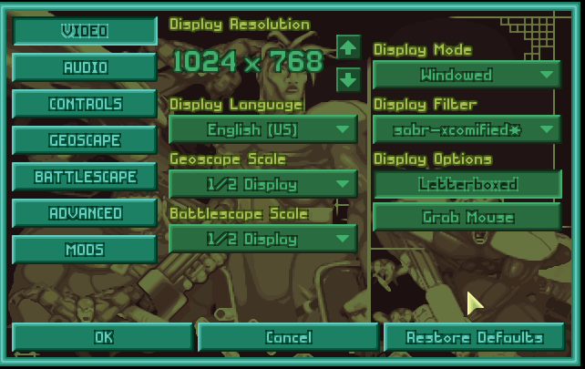

# Data Patch

At <http://openxcom.org/downloads-extras/> get the data patch

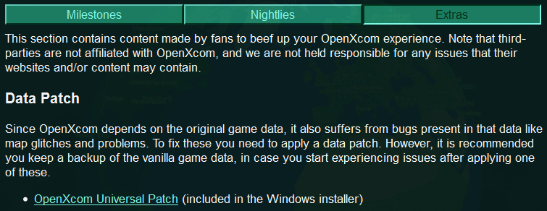

Unzip it over the ‘OpenXcomN\UFO’ directory, like the resource files

# Installing PSX Music (Optional)

Navigate to: <http://www.openxcom.com/mod/ufo-defense-psx-music>

Download it and unzip it to \OpenXcomN\UFO\SOUND

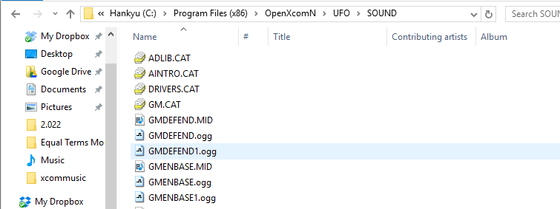

# Installing my ‘Equal Terms 2.0’ Mod

Download the latest version of my mod at: <http://www.openxcom.com/mod/equal-terms-v2-0>

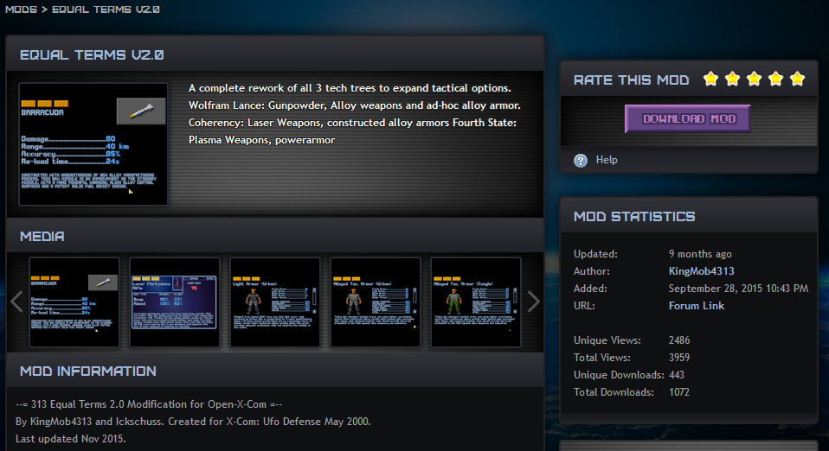

Inside the zip file, you'll find two folders, inside the ‘Prime' folder are the files you want.

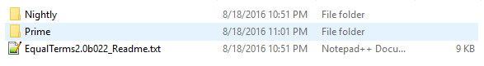



Unzip this folder to the **C:\Program Files\OpenXcom\data Folder.**

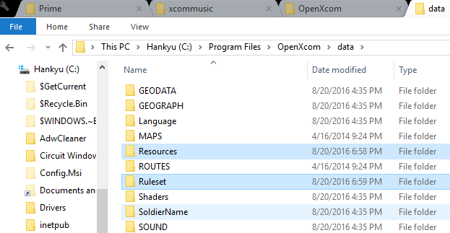

Run the game again.

Go to Options > Mods and select my mod.  **They will be all the mods Prefaced with ‘ET’**

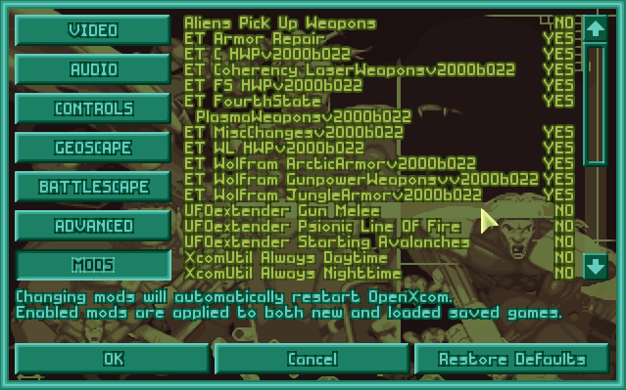

Also turn on ‘UFO Extender Accuracy’ in the **Advanced** Tab

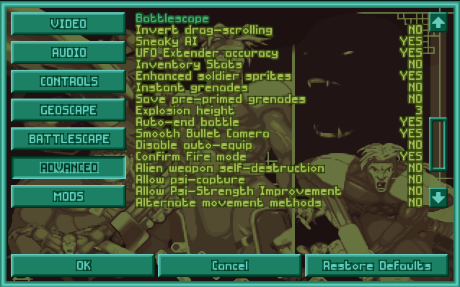

**THIS IS ABSOLUTELY NECESSARY**

And turn on the other suggested options if you like.

(Shown here as well



You should be ready to play.

If you want the file that places people you know in the game every time you start a game, message me.

# Other Suggested Mods

Terrain Pack by Hobbes:

<http://www.openxcom.com/mod/terrain-pack>

Luke’s Extra UFOs (Read the comments on the mod)

<http://www.openxcom.com/mod/lukes-extra-ufos>

Improved Living Quarters

<http://openxcom.org/forum/index.php?topic=2806.0>

For any other questions, check: <http://ufopaedia.org/index.php/OpenXcom>